Conclusions of the 1st
Central European Hydrogen Technology Forum H2POLAND

People can’t stop talking about the first edition of the Central European Hydrogen Technology Forum H2POLAND. Two days, three stages, nearly 100 speakers and over 1500 guests from all over Europe participating in conferences, panels and fairs. There was no doubt as to the legitimacy or the need to introduce hydrogen technologies on a large scale. Hydrogen is no longer just a dream of the future, but a matter of here and now. Representatives of hydrogen valleys, local governments, the world of science and business not only presented the achievements to date, but also put forward concrete solutions necessary for the development of the Polish hydrogen economy.

– A lot is already happening in the Polish legal and economic reality. We have done a great deal of work. We have succeeded in amending the Act on Electromobility and Alternative Fuels - we defined hydrogen as an alternative fuel. Moreover, there is a Polish hydrogen strategy – the initiative on sectoral agreement currently brings together over 200 entities from Poland and abroad. The most important ones for us are Polish companies and universities. We wanted to exploit the potential of Polish intellectual thought. The main task of this economic sector is to use Polish contribution. The construction of a new economic sector should envisage a 10-year plan forward. Our goal is to ensure that Polish entrepreneurs have the largest share in the entire value chain – said Ireneusz Zyska, Secretary of State, Government Plenipotentiary for Renewable Sources, Ministry of Climate and Environment.

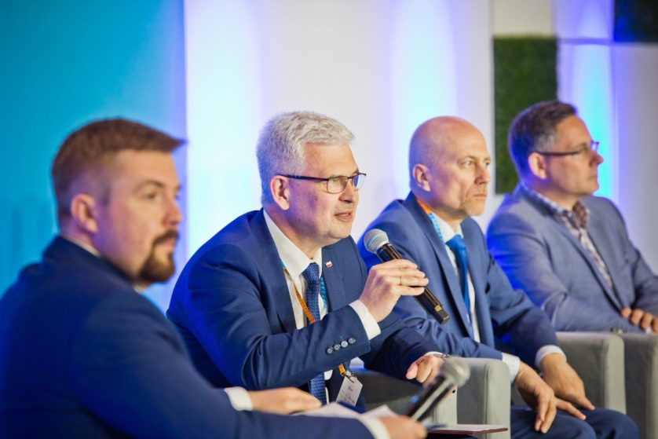

Common objectives and clear rules of the game

– The goal is simple – according to the government’s 2030 agenda, hydrogen is to provide two gigawatts of energy in Poland, and our country is to be included in the European transmission network of this fuel. However, there are many challenges ahead of us, including in terms of legal changes and technology development. We are not only the organiser of this event; as a Group, we are one of the signatories to the Sectoral Agreement for the Development of the Hydrogen Economy. We are obliged to promote this direction of change – emphasised President of the MTP Poznań Expo Tomasz Kobierski during the opening of the Forum.
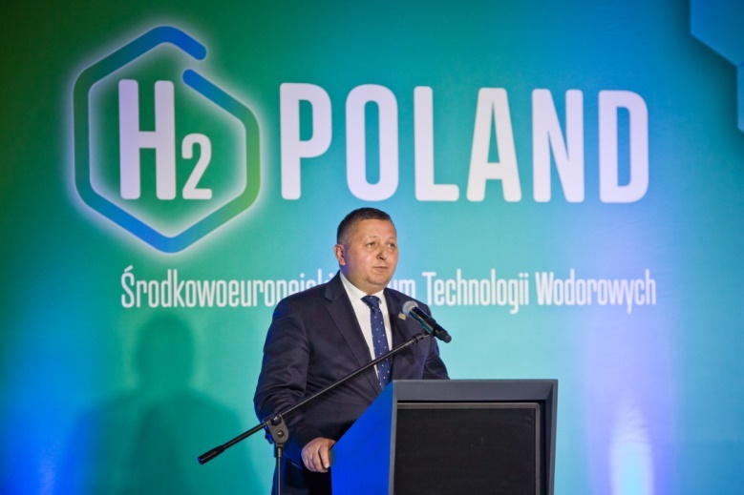

Wielkopolska, Guest Region of H2POLAND, was one of the first regions in Poland to begin the process of building the hydrogen economy, seeing the opportunity and the benefits of developing hydrogen technologies. When speaking about actions to date, international cooperation, and ambitious plans
for the future, Marek Woźniak, Marshal of the Wielkopolska Voivodship, emphasised the significant position of this part of the country in promoting hydrogen technologies in Poland.
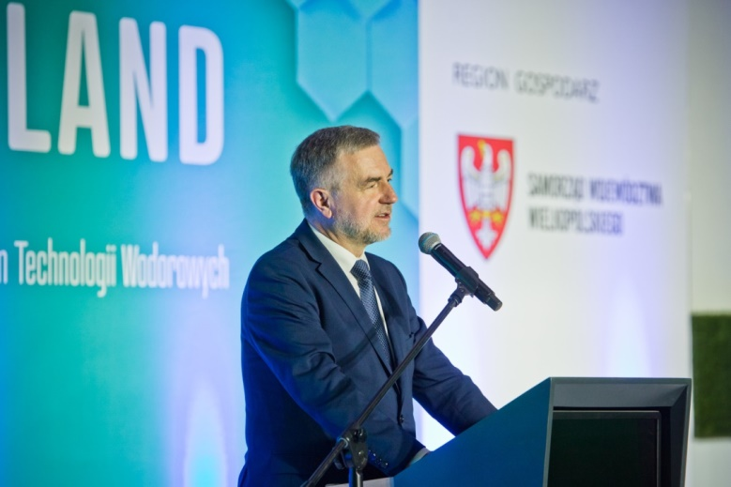

– Green hydrogen is essential so that we can put an end to Europe’s dependence on an unreliable and dangerous supplier such as Russia. That is why we have doubled our 2030 targets in our new Repower EU Plan. Every year, we want to produce 10 million tonnes of renewable hydrogen in the European Union. We want to import an additional 10 million tonnes from abroad. This quantity can replace 50 billion cubic metres of imported Russian gas per year – President of the European Commission Ursula von der Leyen said during her inaugural speech. – We need to develop a European hydrogen economy urgently. I stand here today to say that the European Commission is a partner for you in these efforts – she added, emphasising the actions that the European Commission is taking to speed up the transition to hydrogen. – First of all, we provide this industry with the predictability it needs. We also ensure huge public investment and cooperation between private and research sectors. Our next step was the recent launch of the Clean Hydrogen Partnership. It will provide an additional billion of euros for research and innovation. There will also be another billion from the industry – the President enumerated. In accordance with the President’s declaration, on the second day of the H2POLAND Forum, the European Commission adopted the Ecological Hydrogen Regulatory Package.
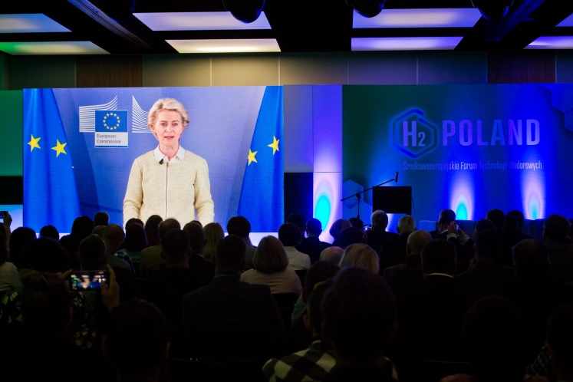

The first day of the H2POLAND Forum was dominated by discussions on the challenges and tasks faced by local governments and businesses entering the hydrogen era. The inaugural debate whose main theme concerned energy transition in the context of the past coronavirus pandemic, the ongoing war in Ukraine, and the sources of acquiring low-carbon hydrogen was attended by: Marek Woźniak, Marshal of the Wielkopolska Voivodship, Miyajima Akio, Japan’s Ambassador to Poland, Józef Węgrecki, Member of the Management Board for Operational Affairs at PKN ORLEN, Reiner Block, CEO Division Industry Service TUV SUD, Grzegorz Pawelec, Vice President of Hydrogen Europe and Jarosław Filipczak, President of the Regional Pomeranian Chamber of Commerce.

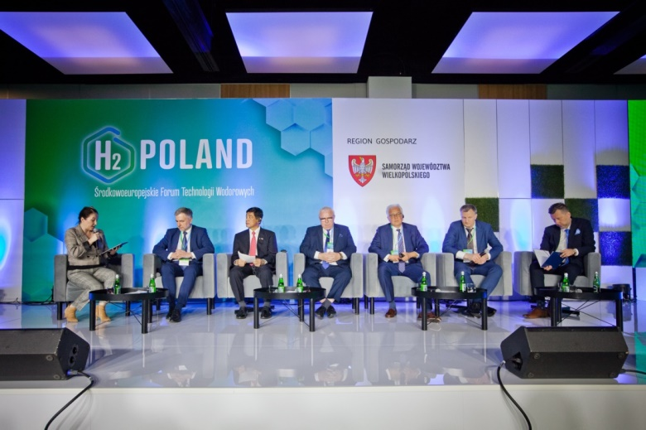

Hydrogen partnerships

Poznań Airport has started the decarbonisation process, the first step of which is the agreement with the international group TÜV SÜD. The company will help in the production of green hydrogen through the airport. The installed photovoltaic panels produce energy which, as a result of electrolysis of accumulated rainwater from hardened surfaces of the airport, will be converted into green hydrogen. The entire investment will begin this year and its implementation will be based on EU funds. If the project succeeds, soon there will be Polish hydrogen buses running at the Poznań Airport.

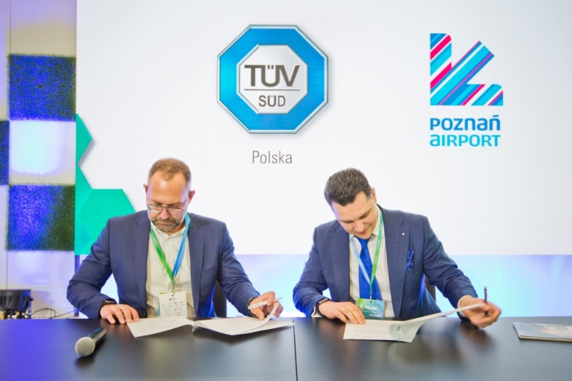

During the Forum, Hynfra and TÜV SÜD signed a strategic global agreement covering certification of investment projects in Poland, Portugal, Oman, and the Arab Emirates in accordance with the highest EU standards. The companies will cooperate in new energy initiatives, decarbonisation, ammonia production, and hydrogen technologies. The contractual value of the investments is estimated at EUR 4.5 billion. – Hydrogen cannot be limited to the role of a new crude oil that drives transport, as its growing presence in our everyday lives will force a change in the functioning of all industries and sectors”, pointed out Tomoho Umeda, President of the Management Board of Hynfra and a guest to the H2POLAND Forum.

Józef Węgrecki, Member of the Management Board for Operational Affairs at PKN ORLEN and Artur Fryczkowski, Vice President and Director of Sales and Business Development at Alstom in Poland, Ukraine and the Baltic States, signed an agreement on strategic cooperation with Alstom for emission-free supplies of green trains and hydrogen fuel for public rail transport. The concern, which consistently implements the hydrogen strategy that was announced this year, will provide refuelling infrastructure for trains produced by Alstom. It’s possible that the first hydrogen vehicles will be put into service on regional lines within two years.
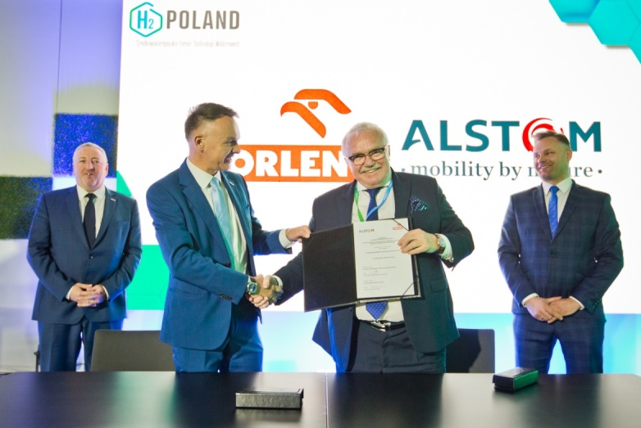

Local societies and new technologies
Do regions need hydrogen to be competitive? Can hydrogen be defended? Are societies ready for the challenges? These were some of the questions asked by Hoon-min LIM, Ambassador of the Republic of South Korea, Jacek Bogusławski, Member of the Management Board of the Wielkopolskie Voivodship, Prof. Jörg Steinbach, PhD. Eng., Minister of Economic Affairs, Labour and Energy of the Energy of the State of Brandenburg, Władysław Ortyl, Marshal of the Podkarpackie Voivodship, Mieczysław Struk, Marshal of the Pomeranian Voivodship, Janina Ewa Orzełowska, Member of the Management Board of the Mazowieckie Voivodship.

– The climate is changing - if we don’t change the way we exploit the environment today, it may be too late. We must take care of the people so that they can have a healthy life - we must take on the challenges presented by the climate and the economy. If we don’t start working towards hydrogen with entrepreneurs, institutions, and local governments, we’ll come to a point of no return. I am confident that the society will be open to hydrogen solutions – as appealed by Janina Ewa Orzełowska, Member of the Management Board of the Mazowieckie Voivodship.
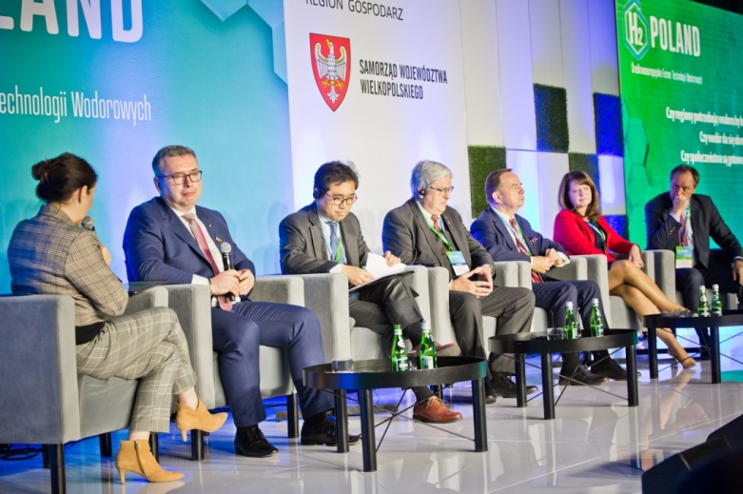
– In South Korea, we believe that hydrogen is the only energy resource that can replace fossil fuels. By investing in this sector intensively, perhaps we will be a pioneer in the field. The 15 largest Korean companies entered into an agreement to create huge investments in hydrogen energy by 2030. Subsidies for purchase of hydrogen as a fuel and hydrogen cars is a way in which the society will accept the transition to hydrogen economy – said Hoon-min LIM, Ambassador of the Republic of South Korea.

– There will be no transformation without the approval of local communities. We have to show people that they are not at risk and that they are safe – Jacek Bogusławski, Member of the Management Board of the Wielkopolskie Voivodship, pointed out the key elements of the activities.
– We have been talking about hydrogen for 20 years, but there is still no discussion about the advantages for small communities. Small communities can manage the budget in a different way, releasing funds which were so far earmarked for energy generation: they can build kindergartens, recreational facilities – as emphasised by Prof. Jörg Steinbach, PhD. Eng., Minister for Economic Affairs, Labour and Energy of the Energy of the State of Brandenburg, where as much as 95% of energy comes from renewable sources.
– In Pomerania, there is a strong interest in new technologies – a good cooperation between companies and institutions enables an actual change in our country and independence from fossil fuels. The fundamental issue in the social discourse - which is absolutely needed - is the issue of security. It is worth showing to the public how hydrogen technologies have changed. Scientists, representatives of local governments, and entrepreneurs may convince the society to adopt these technologies – said Mieczysław Struk, Marshal of the Pomeranian Voivodship.
– We, as local governments, must create good conditions, prepare innovation strategies and obtain European funds. We must envisage finances, including for hydrogen solutions – said Władysław Ortyl, Marshal of the Podkarpackie Voivodship, where the first officially registered Hydrogen Valley operates and the first Polish hydrogen bus is manufactured.
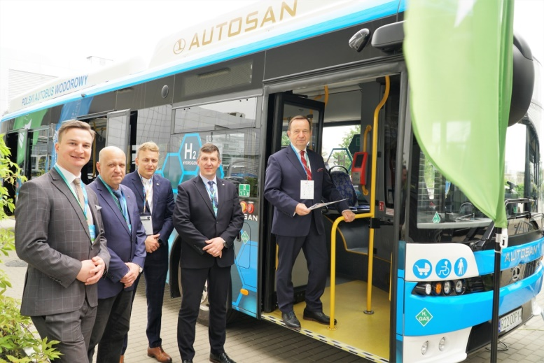
Questions about safety & security
It seems that the type of questions asked at the beginning of the hydrogen talks – whether it’s safe, how to transport it, how to use it in agriculture, etc. – says a lot about the stage of a given operator. The conviction of the safety of hydrogen use is often the beginning of further talks.
– It’s difficult to detect a hydrogen leak, hydrogen is not visible. Hydrogen combined with air may cause an explosion. We need standards. Each valve manufacturer must give his own standards and then guarantee a 50% safety – said Jakub Pikulski, Director at STASTO Automation, Co-creator of the podcast Uwaga Wodór!

– We’re all aware of the hazards linked to hydrogen. But there are special tools for estimating this risk. I can assure you – with appropriate tools, we can ensure the highest safety standards in the transport of hazardous materials – said Katarzyna Skwarek, Senior OHS Inspector at TÜV SÜD Polska Sp. z o.o.

– Yes, hydrogen is safe, but provided that certain technical requirements are met – in Poland, these requirements are regulated by the Office of Technical Inspection (UDT). We see hydrogen as another medium, another gas, another energy carrier with its specific properties of an explosive mixture. However, if we take a broader look at this issue, we’ll see that there’s a lot of such mixtures around us. There’s natural gas which is channelled under streets and blocks, there are petrol stations, and nobody is talking about how dangerous this is. This is why there are units such as the Office of Technical Inspection – to inspect whether this equipment is manufactured and operated in accordance with the standards – as explained by Paweł Smoliński, Director of the Department of Innovation and Development at the Office of Technical Inspection.

– Is hydrogen certification necessary? It is. The industry is both produces and consumes hydrogen. Poland is one of the leading producers of hydrogen in Europe. This has been going on for decades. The objectives to be achieved are decarbonisation and reduction of CO₂ pollution. If we don’t have certification, we will continue to focus on fossil fuels – as pointed out by Michał Przybyszewski, Technical Director at Messer Polska SP. z o.o.

– The certification body must be impartial and independent. It is a third party. It is an entity between customers and producers. It must have appropriate, competent staff. We are talking about both technical and soft competencies – as explained by Paweł Wanatowicz, Energy and Environmental Protection Expert at TÜV SÜD Polska.

– There will be a time that we will talk about hydrogen in 30-40 years’ time with the same degree of comfort as we once talked about hydrocarbon. In a few decades, this problem will be natural for us – said Aleksandra Tracz-Gburzyńska, Head of Safety at SES HYDROGEN S.A.

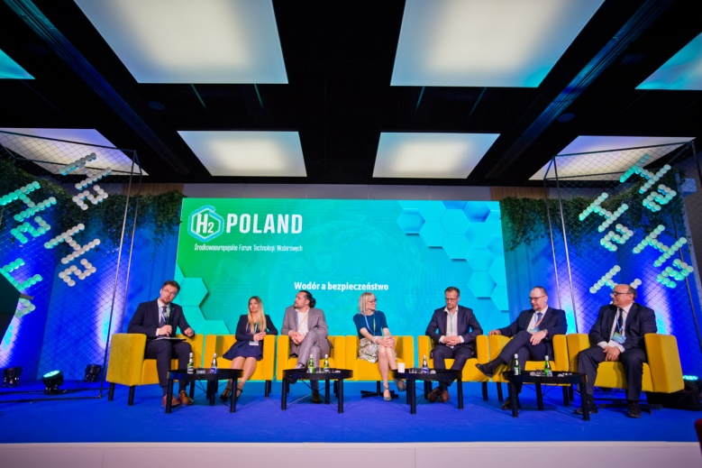
Successful hydrogen ecosystems
Despite all that, the use of hydrogen is increasingly widespread. H2POLAND was an opportunity to meet international experts. Representatives from Germany, Italy, France, and the Netherlands (among others) shared their experience in the introduction of hydrogen technologies.

– Italy worked out a very important plan for restoration and strengthening of resilience following the pandemic crisis in response to the high demand for non-fossil fuels. It envisages investments that will prepare the country for green transformation and digital transformation – said Piergabriele Andreoli, Director of Emilia-Romagna – Energy and Sustainable Development Agency.
– In Hessen, we produce green hydrogen, but most of our resources will come from abroad. It is easier for us to produce energy from offshore wind power stations, just like it is easier for African countries to use photovoltaic cells. The Hessen Government supports more than 100 projects that have already been implemented - e.g. hydrogen car station network, a fleet of hydrogen buses used in public transport, we have also created a sustainable aviation centre, and at the end of the year we will introduce the largest hydrogen rail fleet in public transport – said Karsten McGovern, Managing Director (CEO) of the Hessen Energy Management Agency.
– In Brabant, our objective is to build a green hydrogen production plant by 2030. An important area of our activity is clean energy hubs. Overloaded power networks require management and cooperation between companies, which is why we obtain energy by combining them into a well-managed network chain. We intend to have 10 such hubs by 2030. It is assumed that the first one will offer 22 megawatts of wind, 22 megawatts of sun, and 10 megawatts of hydrogen – as explained by Paul Gosselink from North Brabant Development Agency, Department of Ecosystems.
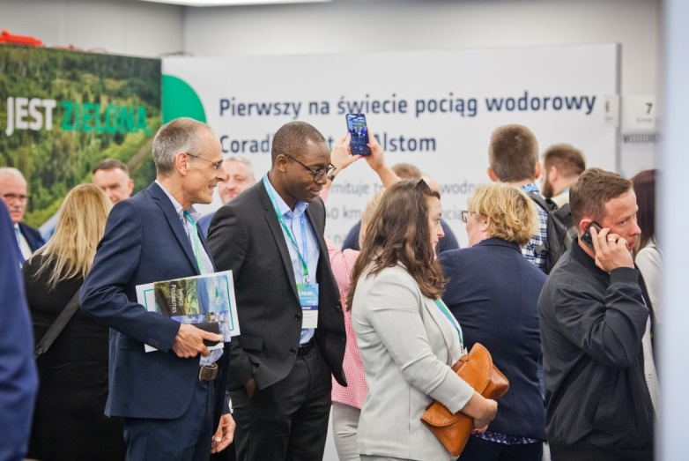
– We want to build a dense hydrogen network that will allow us to connect with suppliers in southern Europe and, at the same time, with consumers in western and northern Europe. Creating hydrogen valleys: we defined 2 areas with serious ambitions of market entry (Pau-Lacq-Tarbes basin and Bordeaux Industrial Port) – as declared by Fayah Assih, Energy Project Manager, Development and Innovation Agency of Nouvelle-Aquitaine.
– We firmly believe that what is happening in Japan in terms of development of hydrogen technologies is a huge opportunity for Europe as well. Green energy is our goal and a very ambitious target. Without losing sight of this goal, however, right now we have to consider different types of hydrogen: green, grey, blue, yellow. And this is what we think about at Kawasaki – as assured by Nurettin Tekin, PhD., Eng., Hydrogen Product Management at Kawasaki Gas Turbine Europe GmbH
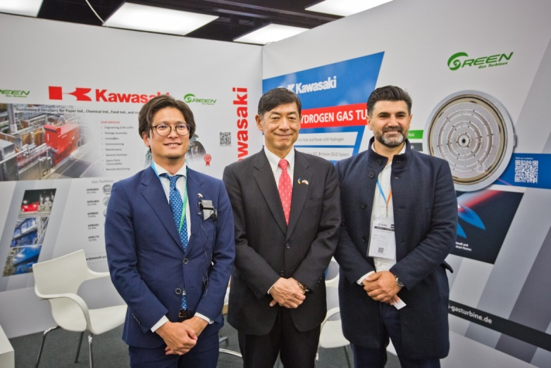
Race for leadership position

Poland’s high position in the current hydrogen producer system in Europe and worldwide is an additional incentive to promote the use of this element in our country. From what has been said by practitioners and experts who are already successfully in the area of hydrogen technology, they overcome difficulties facing them. The catalyst for change and innovation development is competitiveness. Emilia Makarewicz, Head of Hydrogen Projects Development at POLENERGIA S.A., makes the case clear – in order to ensure competitiveness on the green hydrogen market in Poland, we first need a market. However, I hope that such competitiveness will emerge.

According to Sławomir Halbryt, President of the Management Board of Sescom and Ses Hydrogen, the reasons for the current situation are legislative shortcomings – We are all preparing for some kind of jump, but we don’t know in which direction we should be jumping. Entrepreneurs expect regulations and possibilities of obtaining funding. We’re aware that it will be difficult to develop a hydrogen business in Poland without public funds. I don’t know anyone who signed a binding agreement based on current regulations and strategies. The point is to pave the way also for us – the entrepreneurs.

– The group of our customers consists of large companies, but also medium-sized companies, which I am very pleased about. What is a barrier to development? Building permits are a nightmare. Officials who grant permits often don’t have a technical education in terms of hydrogen, so perhaps education is needed, for example, e.g. under the slogan “don’t be afraid of hydrogen” – said Dariusz Jachowicz, CEO of the ASE Group – Automatic Systems Engineering.

– New legislative solutions are a constitution for hydrogen. In this way, we want to stress the importance of these regulations. Public consultations will soon begin. We’ll try to refer to Polish realities. We can follow the example of the best solutions, but this must be consistent with Polish realities. The government and stakeholders have entered into a sectoral agreement. Learning about the expectations of market participants is extremely important – as assured by Ireneusz Zyska, Secretary of State, Government Plenipotentiary for Renewable Sources, Ministry of Climate and Environment.

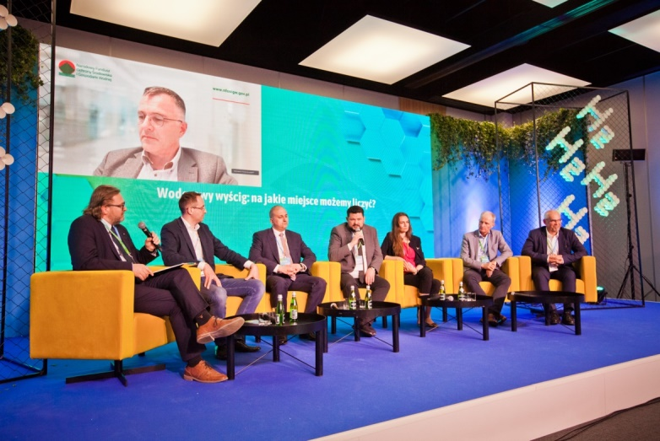

Cooperation among many sectors is fruitful

Despite the difficulties, there are many reasons to be proud of projects and investments carried out.
– The challenges of energy transformation are really huge. We need to combine many technologies from many sectors. There is no time for conflicts and competition – said Bartłomiej Pawluk, Member of the Management Board of Veolia Energia Poznań S.A., Commercial Director of Poznań Veolia Energy Constracting Poland S.A.

– We treat the hydrogen programme as an investment. The first direction is clear to us: the development of green energy. The second one is the complete chain of green hydrogen in Poland. We proceed with electrolyser production, we have already purchased transporters, we operate at two stations for our car fleet. We have also bought a hundred hydrogen cars that are used by our journalists and the management boards of companies. Looking at the hydrogen strategy announced in the EU and Poland, we have been working for one and a half years to create a Polish electrolyser. We would like to produce it in the coming quarter. We have also created our own Polish hydrogen bus, which has already been approved for the European Union. Building this chain will allow to begin our “hydrogen adventure” – said Maciej Koński, Project Manager, Hydrogen, Polsat Plus Group.

– We have created a research programme. We have introduced a number of innovative solutions that create the synergy effect. We work together to combine science and business. Entrepreneurs come to us with an issue and receive a response from us within 15 days with proposed solution – as explained by Artur Kozłowski, PhD, Eng., Representative of Łukasiewicz Research Network – Institute of Innovative Technology EMAG

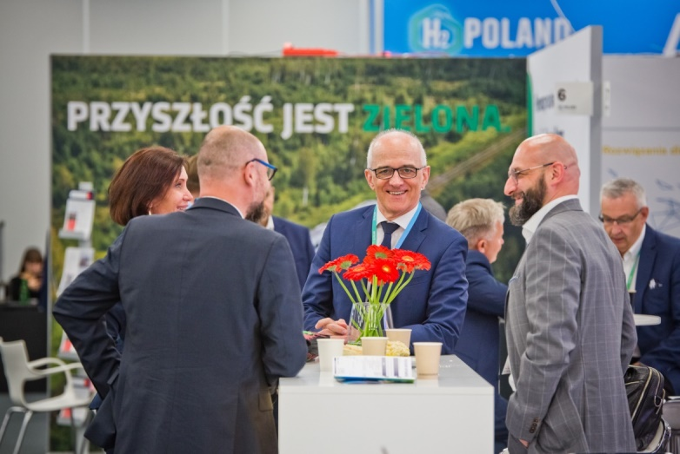

– PKN ORLEN, the leading multienergy company in Central and Eastern Europe, will earmark by 2030 as much as PLN 7.4 billion for investments that will enable development in terms of low- and zero-emission hydrogen based on renewable energy sources and municipal waste treatment technology” – as declared by Grzegorz Jóźwiak, Director, Alternative Fuels at PKN ORLEN S.A. The expert emphasised that as part of the implementation of the strategy 10 hydrogen hubs will be created by the end of this decade, and drivers in Poland, the Czech Republic, and Slovakia will be able to use the network of over 100 hydrogen refuelling stations. – Investments in green hydrogen will support the transformation of the ORLEN Group towards a carbon-neutral group and strengthen the energy security of Poland and of the entire region – Grzegorz Jóźwiak added.

– There is a pilot project aimed at the construction of a hydrogen heat and power plant network. There is a hydrogen bus standing in front of the hall – it is the work of one of our members. Photovoltaics also begins to work with hydrogen technologies. There is also a long-term vision of building a hydrogen-powered aviation engine. It is estimated that this revolution will take place in 2035/2040. We will soon begin research into hydrogen combustion in the aviation industry. All this is done by combining science and business – said Prof. Jarosław Sęp, President of the Podkarpackie Hydrogen Valley Association, Rzeszów University of Technology.

– We successfully strive for the implementation of city development strategy – including the modernisation of urban rolling stock. Our ambition was also to include a hydrogen vehicle in this rolling stock. By 7 July 2022, Solaris will deliver a hydrogen bus to Konin. The bus will expand the rolling stock of MZK Konin. I do not want to compete with anyone. It is not about being the first local government with a hydrogen bus. The most important thing is that we implement the city development strategy and meet the expectations of the society, which wants Konin to become a green, ecological zone – said Piotr Korytkowski, President of the City of Konin.
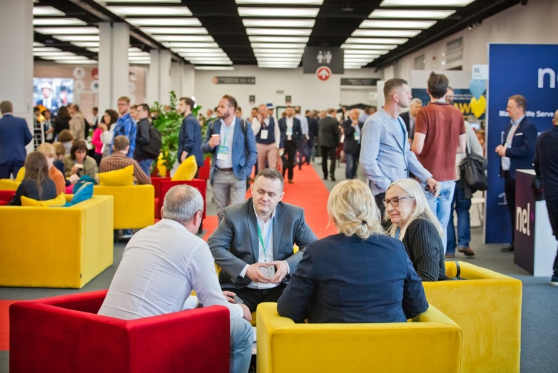

Funding of hydrogen projects

– We are at the beginning of our road towards the hydrogen economy, which will take the next few decades. As a Fund, our role is specific. We support all initiatives and projects. We have a national research and development centre ahead of us. We support mature projects, similarly to commercial banks, but we do it on preferential terms – as explained by Piotr Dowżenko, Department Director, National Fund for Environmental Protection and Water Management.

– We cannot live with a fallacy that there is no money for hydrogen. Apart from European funds, national measures are also effective in financing the development of this technology. Our report, which was issued in December 2021, included a breakdown of various types of funds available to companies and institutions developing hydrogen programmes, including, among others, development banks’ offers with non-repayable loans, among other things. In the European perspective, we have programmes worth many billions of euros, with Connecting Europe Facility being noteworthy. The facility forces wise consortium development and stresses that a given entity deserves to obtain funds – as enumerated by Kamil Wyszkowski, Country Representative, Executive Director, UN GLOBAL COMPACT NETWORK POLAND (UN GCNP)
– We want to support hydrogen valleys because we want to be as close as possible to the development of these technologies. If we do not acknowledge the entire risk of the hydrogen revolution, we will be afraid of it. We carry the baggage of experience to extend our knowledge of how to finance these activities. We act simultaneously – we acquire this knowledge and we recognise how this market will develop. We have risks for insurance institutions. All aspects are necessary to process co-financing efficiently – said Adam Żelezik, Director of the Office for Strategic Initiatives, 3W Initiative, Bank Gospodarstwa Krajowego
There are many available funds despite the current situation. We have many advantages as Poland, but for investors it is important how green a given region will become. Our role is to identify appropriate locations – as argued by Prof. Tomasz Gackowski, Managing Director for Strategic Development, Industrial Development Agency (ARP).
– The Regional Pomeranian Chamber of Commerce manages the first cluster of hydrogen technologies in Poland. The acquisition of EU funds is our everyday life, we constantly learn it, and we practice cooperation on the international stage. We focus to a large extent on providing education to specialist staff who will be the basis for technological transformation – said Ewa Mazur, Energy and Climate Manager, Regional Pomeranian Chamber of Commerce
– Activities related to hydrogen research and innovations can surely get their “piece of pie” in the Horizon Europe programme. The budget for Poland in this programme will be allocated to the amount justified under the initiative of Polish companies and institutions – said Maria Śmietanka, PhD, Deputy Director of National Contact Point at the National Centre for Research and Development (NCBR).
The experts agreed that the financing should cover the entire hydrogen chain – production, storage, transport, but also education and other areas related to technological transformation. The H2POLAND Forum has created a unique opportunity to learn about the opinions and experiences of nearly 100 experts, including: Miyajima Akio, Japan’s Ambassador to Poland, Reiner Block, CEO Division Industry Service TUV SUD, Grzegorz Pawelec, Director, Intelligence, Jarosław Filipczak, President of the Regional Pomeranian Chamber of Commerce, Cluster of Hydrogen Technologies, Michał Tarka, Head of the ENERGY TEAM in SMM Legal, Dariusz Pachniewski, Director for Business Development, Hynfra Green Hydrogen Infrastructure, Marek Foltynowicz - Expert at Cluster of Hydrogen Technologies, Jan-Peter Born, PhD, Chairman of the Working Group “Residues” of the Dutch Waste Processing Association (DWMA) and Member of the CEWEP Residues Working Group and the Scientific & Technical Advisory Council of CEWEP, Maciej Malicki, Business Development Manager Large Industries at Air Liquide Polska Sp. z o.o., Helena Cygnar, Head of Exploration & Concession Office at LOTOS Petrobaltic S.A., Jarosław Zacharski, Head of the Regional Institute of Geology – Polish Geological Institute – National Research Institute (PIG-PIB), Florian Frank, Head of Unit Science and Research, Embassy of the Federal Republic of Germany, Paweł Piotrowicz, Expert on energy market and hydrogen technologies, TÜV SÜD Polska, Przemysław Rudź, Polish Space Agency, Maciej Galiński, PhD, Professor at the Poznań University of Technology, Andrzej Ziółkowski, PhD, Eng., Poznań University of Technology, Piotr Woźny, President of the Management Board of ZE PAK S.A. Piotr Pustoszkin, Business Development Director Poland, Ukraine & Baltics ALSTOM ZWUS SP. Z O.O., Aleksander Sobolewski, PhD, Institute for Chemical Processing of Coal, Agnieszka Spirydowicz, President of the Zgorzelecki Cluster for RSE and Energy Efficiency Development – Zklaster, Mateusz Sołtysiak, Managing Partner at SES HYDROGEN S.A., Bartosz Moszowski, NITROSYNCAT Research and Development Centre at Łukasiewicz Research Network – New Chemical Syntheses Institute, Michał Siedlecki, Bank Ochrony Środowiska S.A., Katarzyna Kierzek Koperska, Wielkopolskie Region Development Fund, Henryk Kubiczek, Head of Corporate Strategy & Development Department, Azoty Group, Tomasz Pelc, Nexus Consultants Sp. z o.o., Katarzyna Gruszecka-Spychała, Deputy Mayor of Gdynia, Józef Zajkowski, Head of Sokoły Municipality, Mieczysław Obiedziński, President of the Board of TÜV SÜD Polska, Wiesław Kamieński, Polish Agricultural Hydrogen Valley. Podlaska Regional Development Foundation, Wojciech Mojkowski, Podlasie Centre for Agricultural Advice in Szepietowo, Jerzy Wierzbicki, Polish Association of Beef Cattle Breeders and Producers, Marcin Parchomiuk, PhD, Eng., Deputy Director for Research and Commercialisation in Łukasiewicz – Electrotechnical Institute, Katarzyna Barańska, PhD, Partner, Head of Decarbonisation Osborne Clarke Olkiewicz Świerzewski i Wspólnicy S.K.A., Anna Szóstakiewicz, Hydrogen Expert, KEZO Research Centre PAS, Paweł Trojanowski, Business Development Manager, Sescom S.A., Joanna Kubit, Director of Ignacy Łukasiewicz Oil and Gas School Complex in Krosno, Jakub Koper, PhD, Deputy Director, Institute for Educational Research, Grzegorz Kulczykowski, Eng., Coordinator for Security Academy Training, EKO-KONSULT Sp. z o.o., Marek Marcisz, Energy Specialist, TÜV SÜD Polska, Delfina Rogowska, PhD, Eng., Head of KZR System Office, Beata Superson-Polowiec, Managing Partner, Polowiec i wspólnicy sp.j., Artur Labus, Head of Service Department, TÜV SÜD Polska, Paweł Grzejszczak, DZP Legal Firm, Rafał Frączek, Eco Konsult, Mateusz Stańczyk, Attorney-at-law, Partner SMM LEGAL, Beata Szymanowska, Proxy of the Management Board of the Company responsible for the implementation of the hydrogen programme, Manager of Research and Development Department, the Management Board of Maritime Port of Gdynia S.A., Walerian Majewski, Coordinator of the Pomeranian Hydrogen Valley, Łukasz Gałczyński, Member of the Supervisory Board of ARP S.A., acting Vice President of the Management Board, Agnieszka Jakubiak, Operational Expert of Internal Experts Section, National Centre for Research and Development.

The first Central European Hydrogen Technology Forum H2POLAND was organised by the MTP Poznań Expo. The cooperation was ensured by: Region Host: Local Government of Wielkopolskie Voivodship; Co-organisers of H2POLAND Conference: Regional Pomeranian Chamber of Commerce – Cluster of Hydrogen Technologies; General Partner: PKN ORLEN S.A.; General Partner – Session Sponsor: Agencja Rozwoju Przemysłu S.A.; Substantive Partner: TÜV SÜD Polska Sp. z o.o.; Legal partner: SMM Legal
Partners: STASTO Automation Sp. z o.o., SES Hydrogen, Lewiatan Confederation, ASE Technology Group, Podkarpackie Voivodship, TOYOTA POLSKA, Łukasiewicz Research Network, ALSTOM, Bank for Environmental Protection (BOŚ), KAWASAKI GAS TURBINE EUROPE
Honorary Patronage over the event: Ministry of Climate and Environment, Ministry of Funds and Regional Policy, Ministry of Agriculture and Rural Development, National Fund for Environmental Protection and Water Management, National Centre for Research and Development, Polish Agency for Enterprise Development, President of the City of Poznań, United Global Compact, Embassy of the Kingdom of Denmark in Poland, Polish Geological Institute – National Research Institute.

The event took place on 17 and 18 May 2022 at the MTP Poznań Expo.

More information can be found at: www.h2poland.com.pl

